**CS435 Database Systems Fall 2015 Lab#4**

**Due Date: Dec. 3, 2015**

Use the following tables to design and implement the Pomona Transit System using any database product and JDBC.

**Trip** ( TripNumber, StartLocationName, DestinationName)

**TripOffering** ( TripNumber, Date, ScheduledStartTime, SecheduledArrivalTime, DriverName, BusID)

**Bus** ( BusID, Model,Year)

**Driver**( DriverName, DriverTelephoneNumber)

**Stop** (StopNumber, StopAddress)

**ActualTripStopInfo** (TripNumber, Date, ScheduledStartTime, StopNumber, SecheduledArrivalTime, ActualStartTime, ActualArrivalTime, NumberOfPassengerIn,

NumberOf PassengerOut)

**TripStopInfo** (TripNumber, StopNumber, SequenceNumber, DrivingTime)

**INITIAL DATABASE VALUES:**

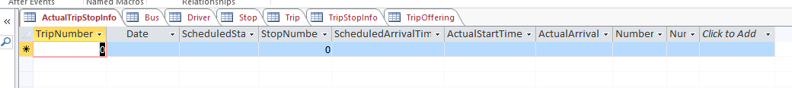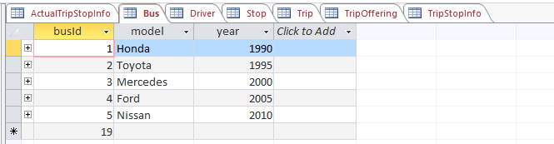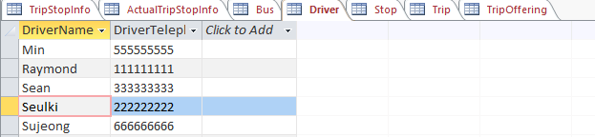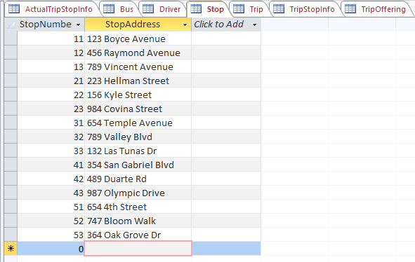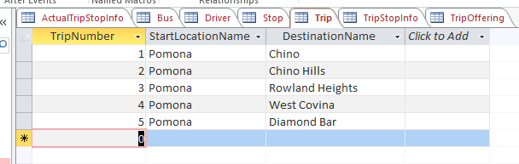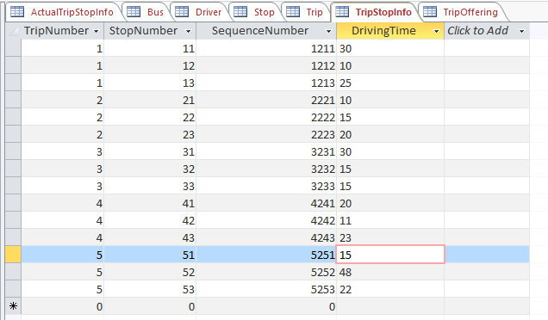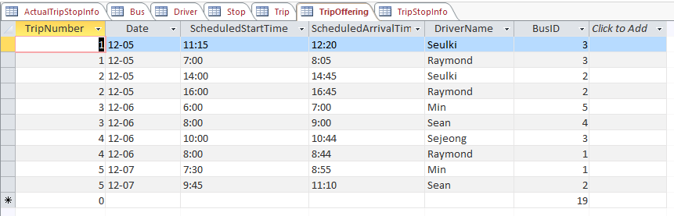

1. Display the schedule of all trips for a given StartLocationName and Destination Name, and Date. In addition to these attributes, the schedule includes: Scheduled StartTime, ScheduledArrivalTime, DriverID, and BusID.

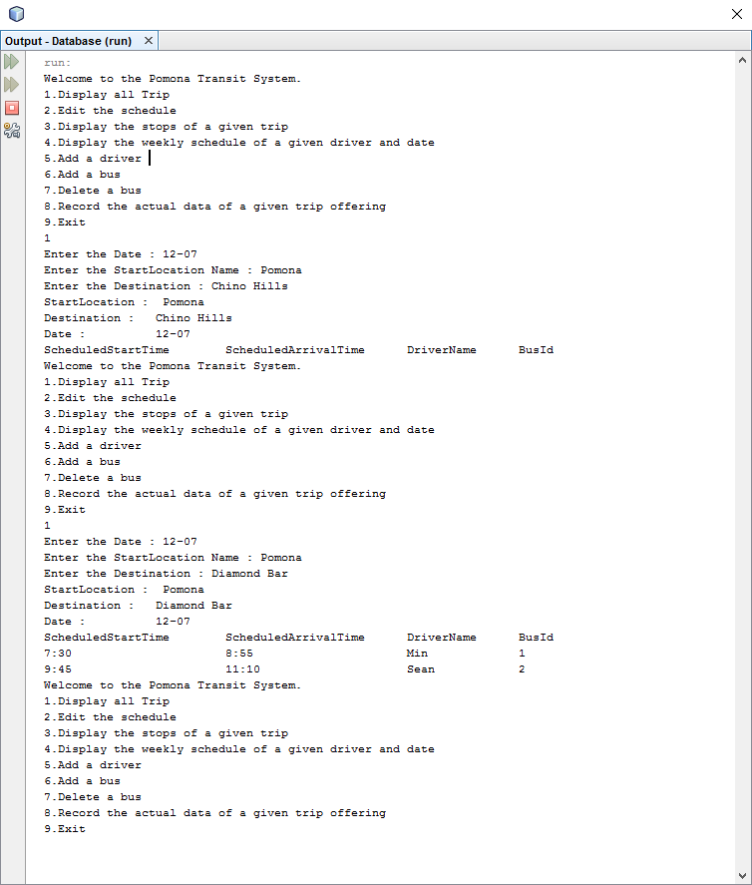

2. Edit the schedule i.e. edit the table of Trip Offering as follows:

-Delete a trip offering specified by Trip#, Date, and ScheduledStartTime;

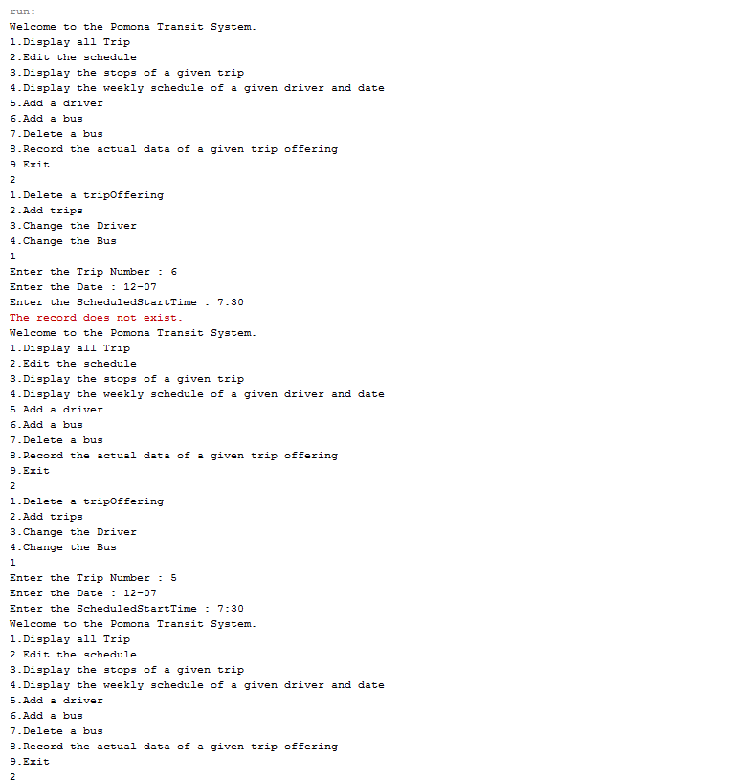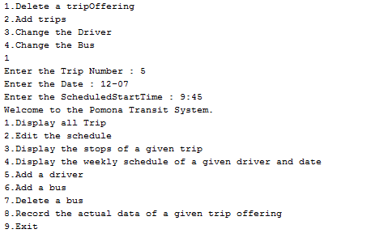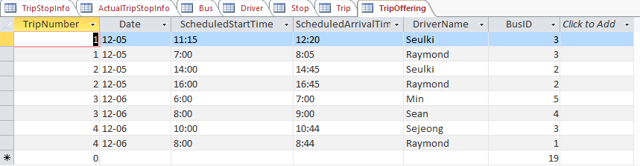

-Add a set of trip offerings assuming the values of all attributes are given (the software asks if you have more trips to enter);

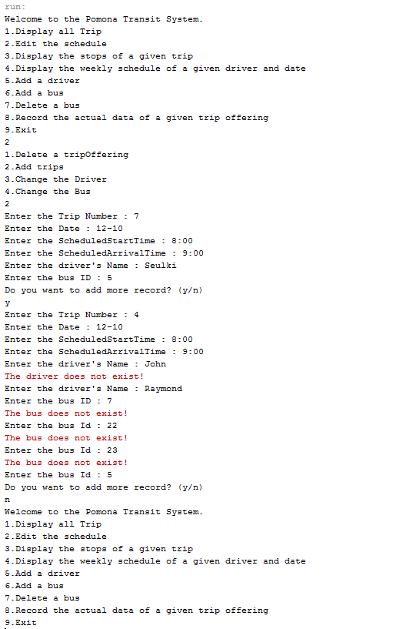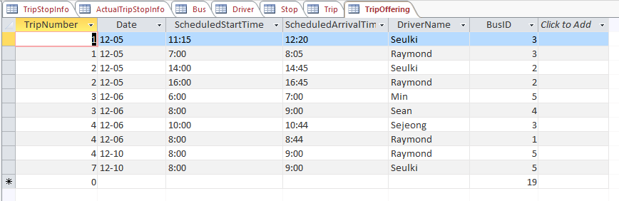

- Change the driver for a given Trip offering (i.e given TripNumber, Date, ScheduledStartTime);

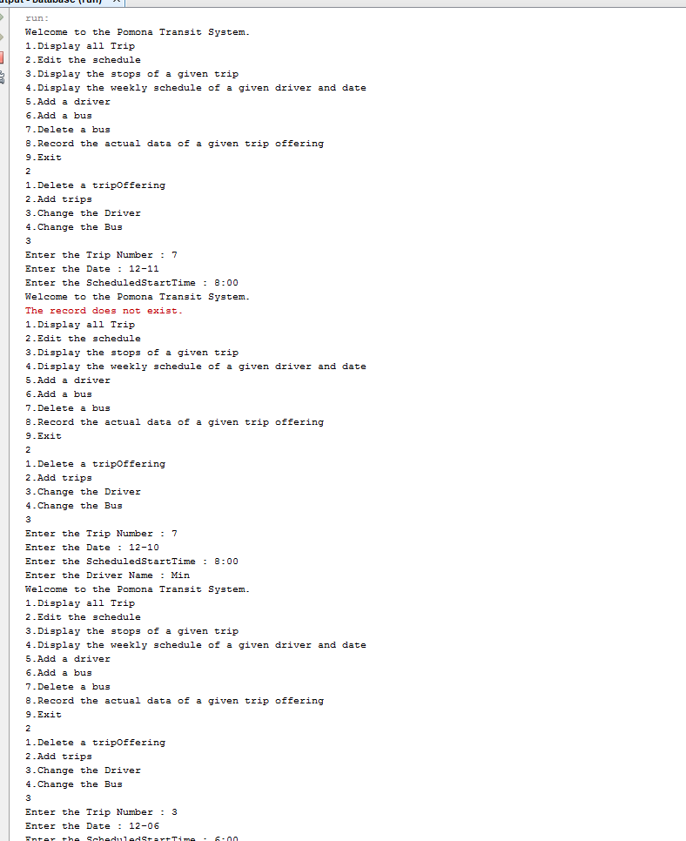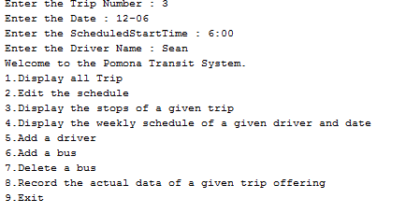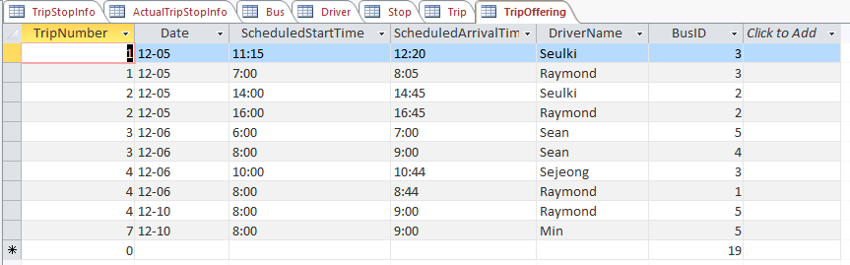

- Change the bus for a given Trip offering.

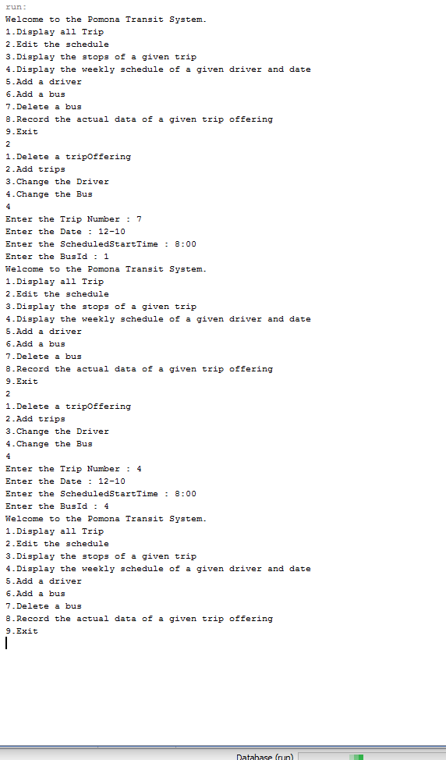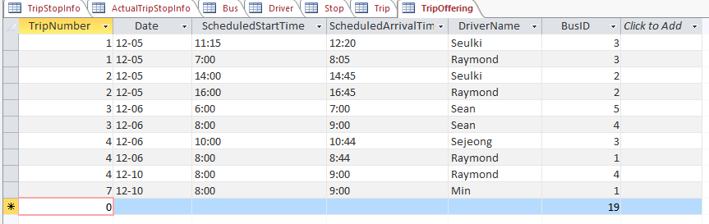

3. Display the stops of a given trip ( i.e. the attributes of the table **TripStopInfo**).

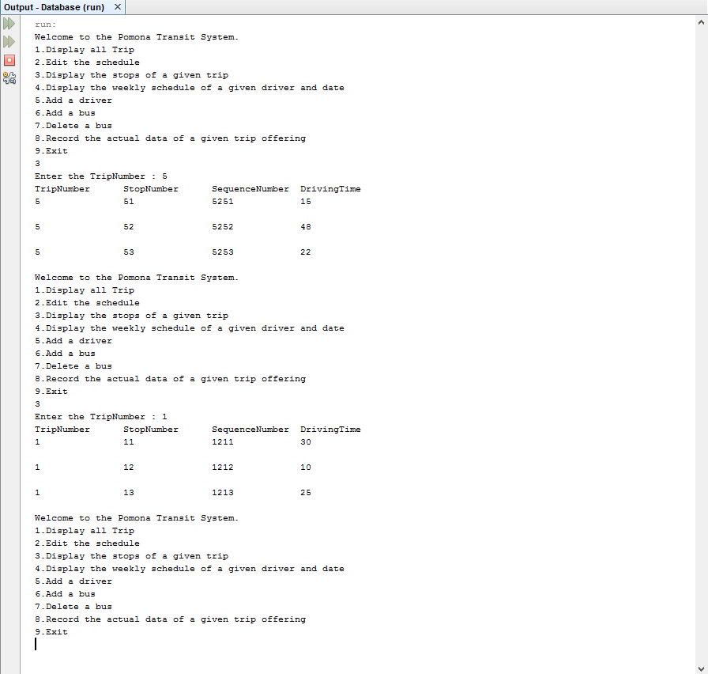

4. Display the weekly schedule of a given driver and date.

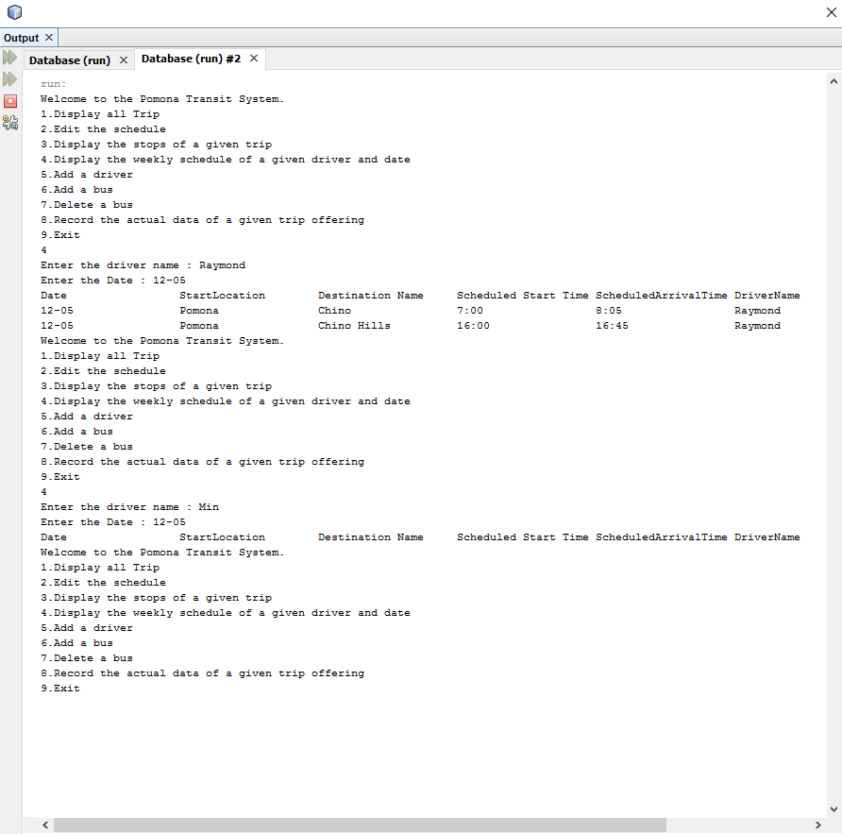

5. Add a driver.

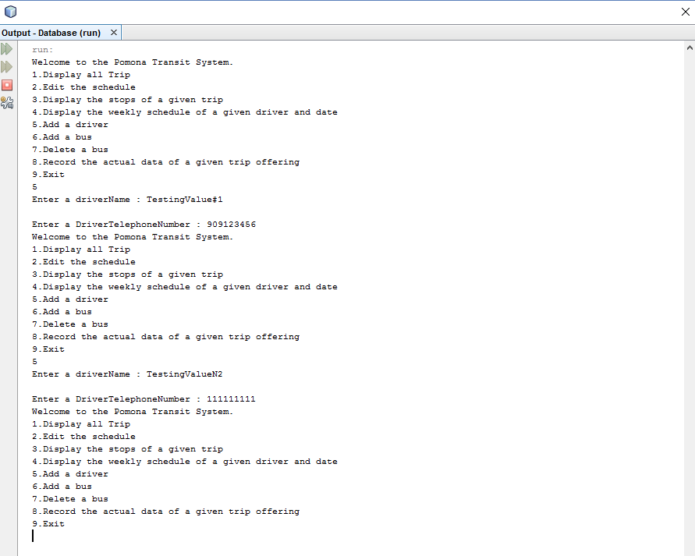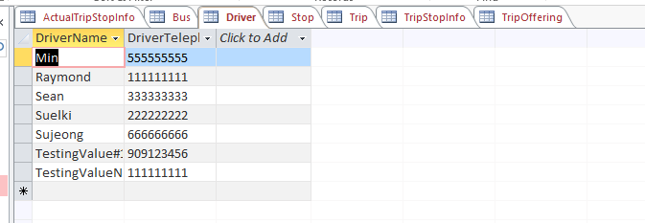

6. Add a bus.

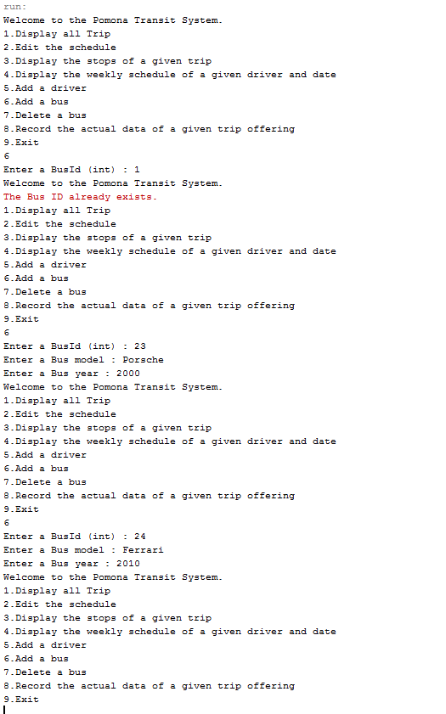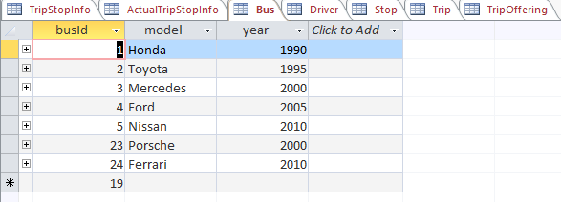

7. Delete a bus.

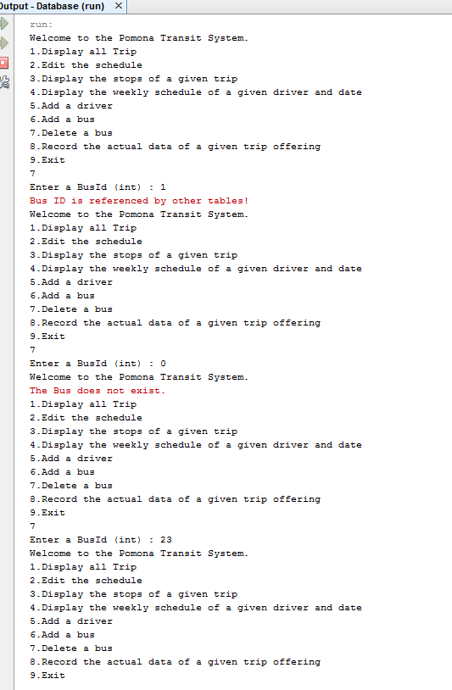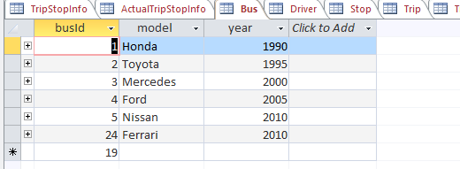

8. Record (insert) the actual data of a given trip offering specified by its key. The actual data include the attributes of the table **ActualTripStopInfo.**

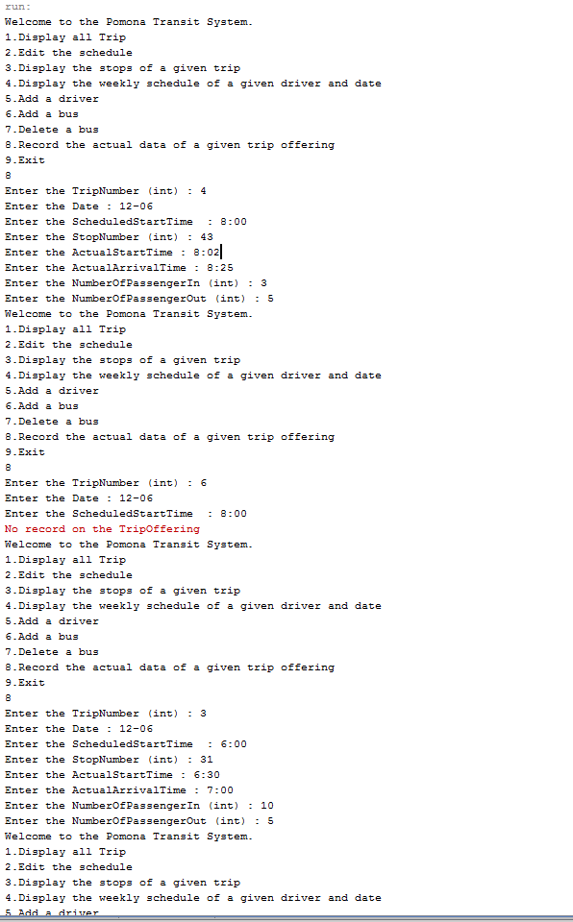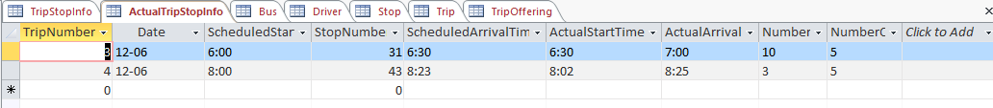

Test your program using several test data for the above transactions.

Please submit a hard copy of your program and a printout of all test data and its output in a large envelope.